Deeplinking to Frankel on desktop and mobile

Overview

The new Frankel Racing Client, which is now active, has changed the way in which we currently deeplink to Racing. It is still possible to link to the same areas within the new client, however the structure and contents of the URLs have changed. Deeplinks you create can be used for both mobile and desktop.

Point to note is that the rules for deeplinking in Racing is different to those in the Sports section of the site. If you are Deeplinking to Horse Racing, Greyhounds and Trotting, you’ll be going through Racing menu and this guide will be appropriate. For Deeplinking of Sports, including Football, Rugby and Golf, the other Kambi Deeplinking guide is for you.

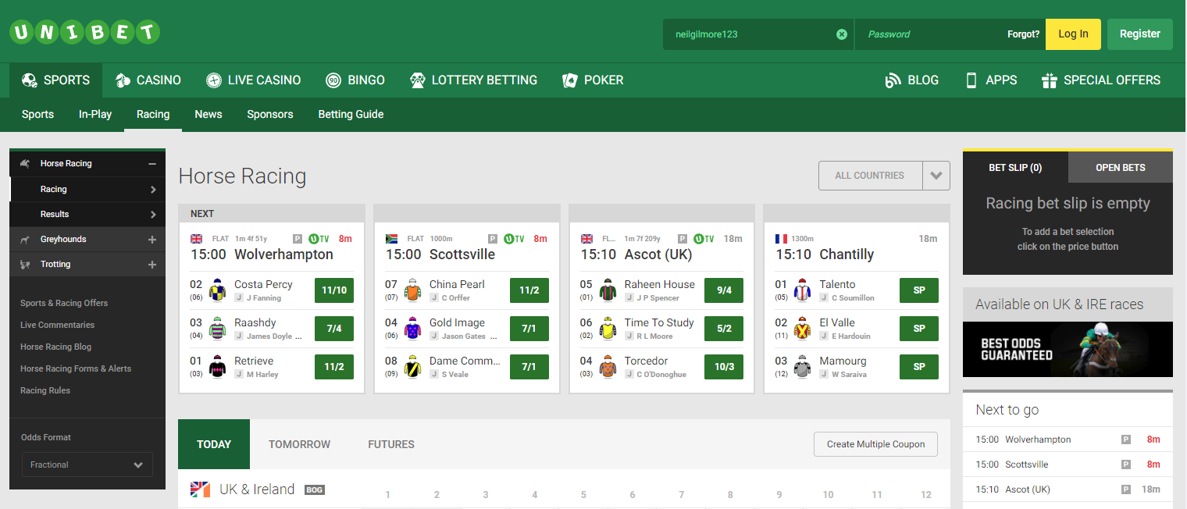
Racing deeplinking comes here

Another difference to note is that the Sports deeplinking will locate the event and generate a betslip on the page. For Racing, the event will be located, but there is no betslip generation currently.

The new URL still contains the {eventKey} required to take you to the page in Unibet for that event, but now the path is slightly different. There is no path distinction between Horse Racing, Greyhounds, and Trotting, other than the {eventKey} will be different.

Old URL - http://www.unibet.co.uk/betting/beta-17121801#/event/201805021500.G.GBR.hove.7/win
New URL - http://www.unibet.co.uk/betting/racing#/event/201805021500.G.GBR.hove.7/win

*** When adding to your adserving link the # needs to be replaced with %23 for tracking purposes. You may find this is not required for some browsers (like Chrome), but to ensure complete cross-browser support, it is advisable complete this step.
The following ‘how to’ guide will give an in depth look into how to deeplink to these different places in the client.

How to Deeplink

To deeplink to Racing, you need to open the betting client and follow these steps (Horse Racing will be used as an example):
Navigate to Sports and then Racing on the client located on the left of the page.

You will end up on the main Racing page:
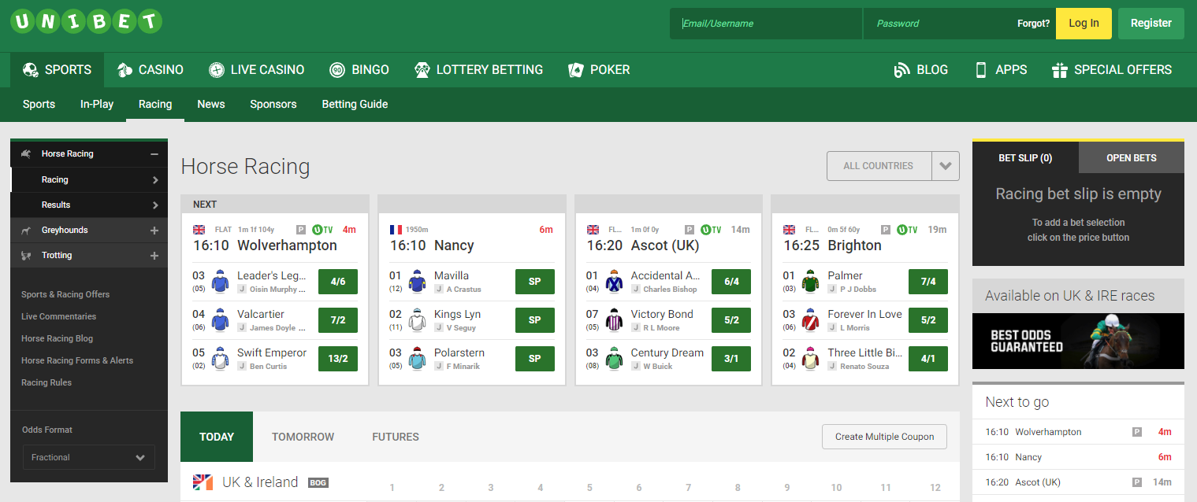

Click an event:
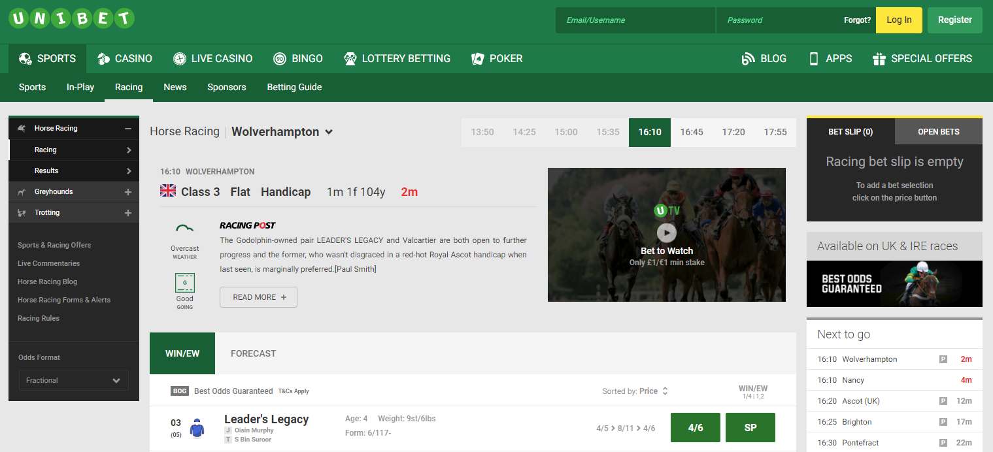

The browser URL will now contain the information you will need for deeplinking

Use everything after the unibet.co.uk. This is the unibetTarget parameter and contains the {eventKey} mentioned above
/betting/racing#/event/201805021500.T.GBR.wolverhampton.5/win

This can be placed into a tracked URL for use by affiliates or into a URL for other channels such as Social or PPC
***Please replace the # with %23. ‘/betting/racing#/event/' would become ‘/betting/racing%23/event/’

The General example of the Deeplinking adserving link to Racing events only –

http://adserving.unibet.com/redirect.aspx?pid=xxxxx&bid=xxxx&unibetTarget=/betting/racing%23/event/{evenyKey}/win

